**Ayesha Sajjad 2022-EE-107**

**Experiment 5**

**Combinational Circuit Design: Seven Segments Display using K-Maps**

**Truthtable for 7 segment display:**

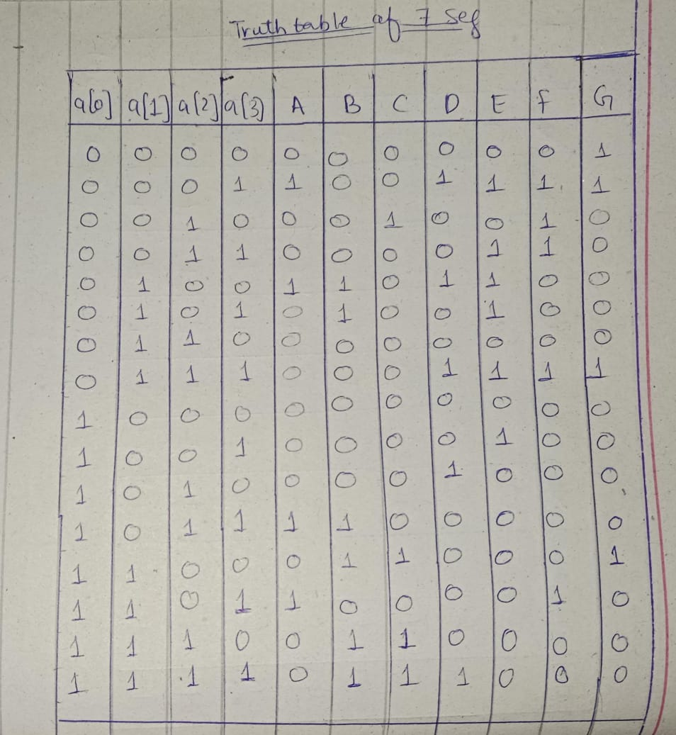

**K map for A:**

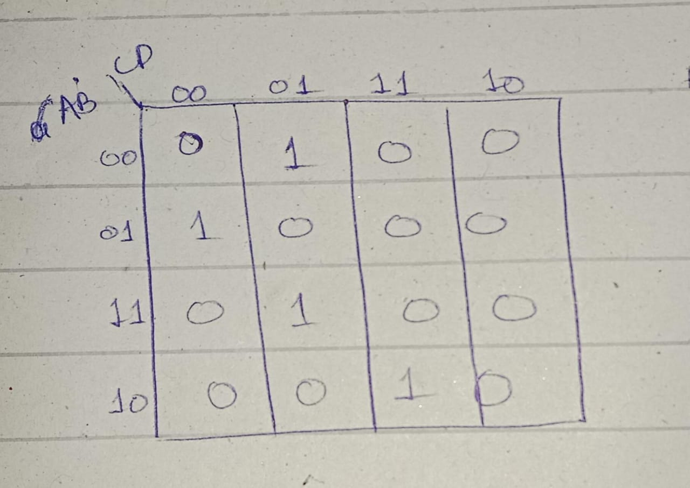

**K Map for B:**

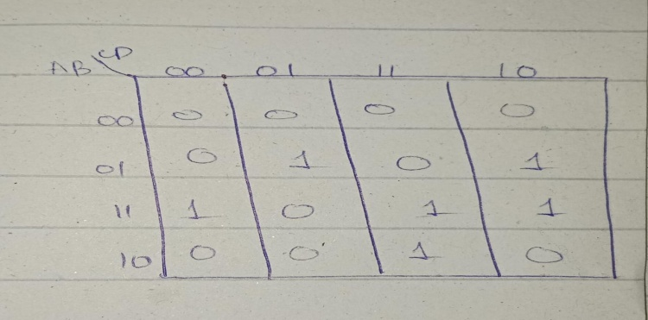

**K map for C:**

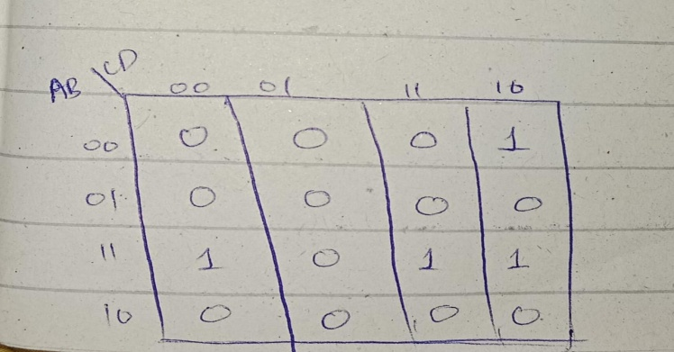

**K map for D:**

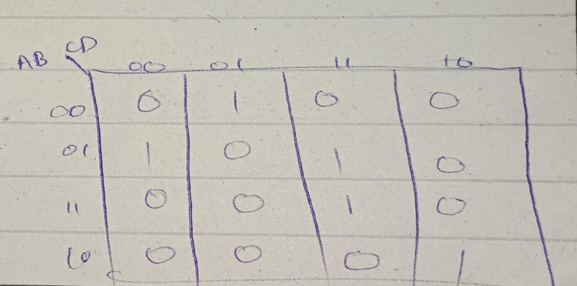

**K map for E**

**:**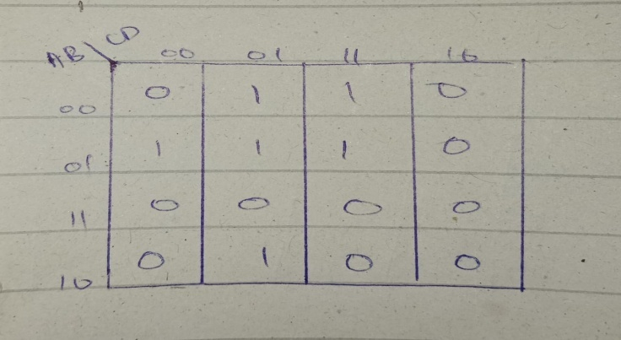

**K map for F:**

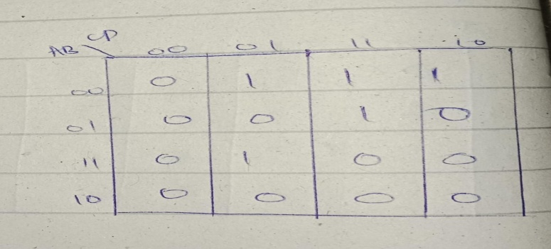

**K map for G:**

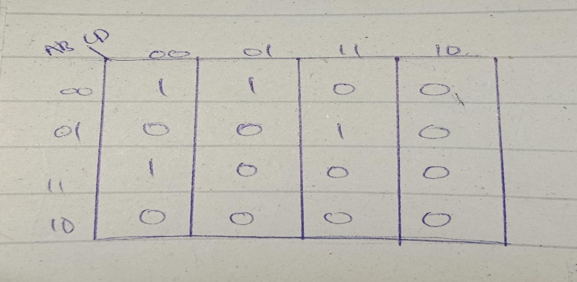

**Truthtable for anode pins:**

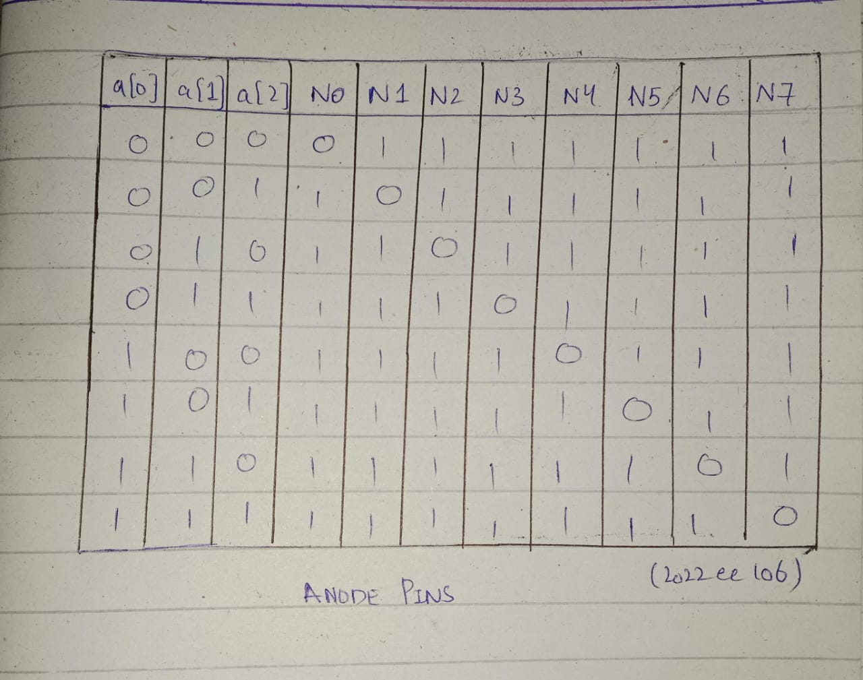

**K map :**

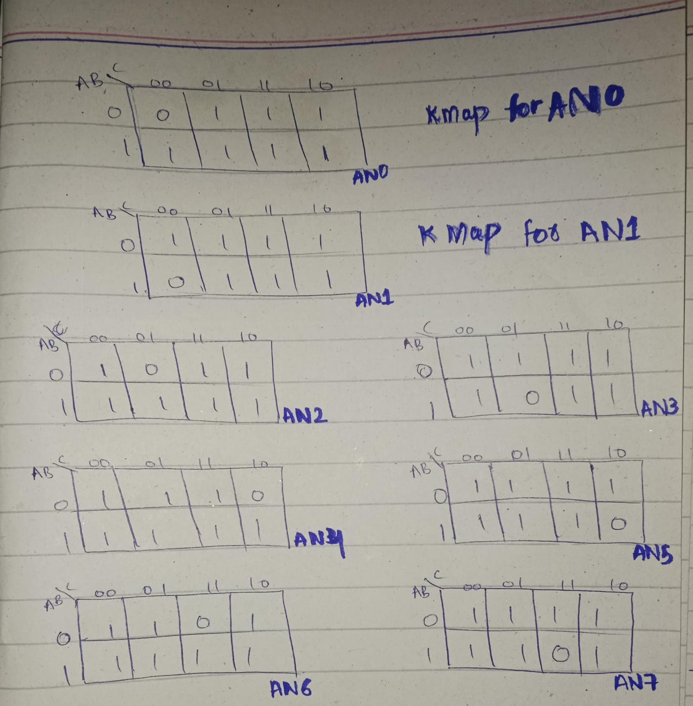

**Circuit diagram inferred by the Xilinx Vivado:**

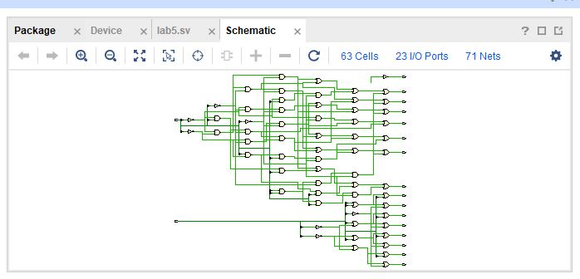

**Combinational delay:**

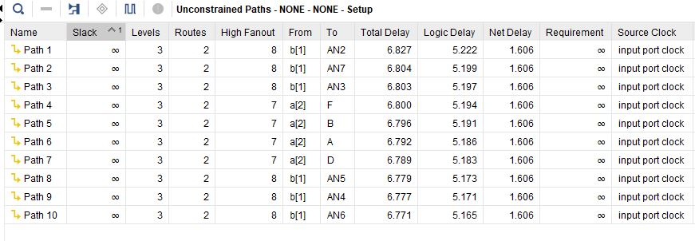

**Resource Utilization Summary:**

